Midterm Submission

**Name**: Akshay Ghatge (991541118)

**Slate Username**: ghatge

Question 1

Part 1

Cut and Paste your PL/SQL Stored Procedure here:

create or replace procedure midpart1 as

begin

DECLARE

low number;

high number;

BEGIN

high := 12; low := 1;

LOOP

Exit WHEN (low=high);

SYS.dbms_output.put_line(low);

IF MOD(high,low)=0

THEN

dbms_output.put_line(':Yes ' ||high ||'is divisible by '|| low);

ELSE

dbms_output.put_line(': No ');

END IF;

low := low+1;

END LOOP;

END;

end midpart1;

Part 2

Take a screenshot of the output window in SQL Developer and paste the image here

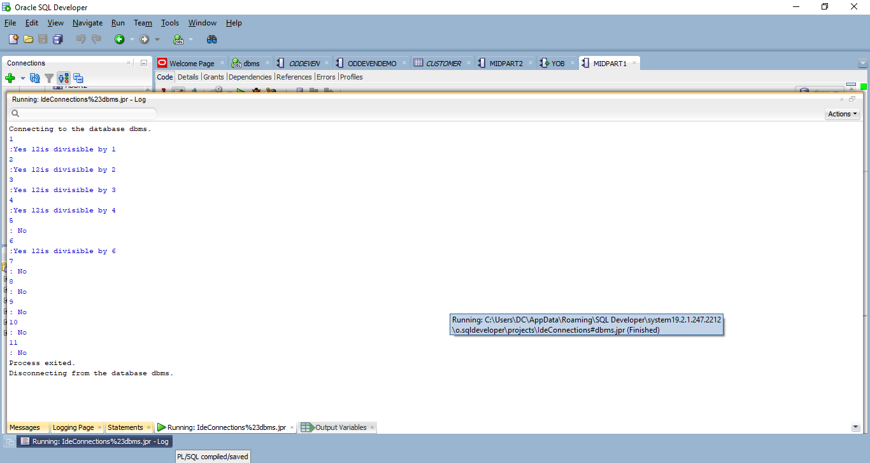

Question 2

Part 1

Cut and Paste your PL/SQL Stored Procedure here:

CREATE OR REPLACE PROCEDURE midpart2

(

dob date

)

AS

BEGIN

DECLARE

age Number;

yearStr Number;

currYear Number;

cursor curr is

SELECT * FROM customer;

currRow Customer%ROWTYPE;

BEGIN

open curr;

currYear := EXTRACT(YEAR FROM TO_DATE(CURRENT_DATE));

LOOP

fetch curr into currRow;

exit when (curr%NOTFOUND);

yearStr := EXTRACT( YEAR FROM TO_DATE(currRow.DOB));

age := currYear-yearStr;

DBMS_OUTPUT.PUT_LINE(currRow.fname || ' ' || currRow.lname || ', age ' || age);

END LOOP;

close curr;

END;

end midpart2;

Part 2

Take a screenshot of your table data and paste the image here

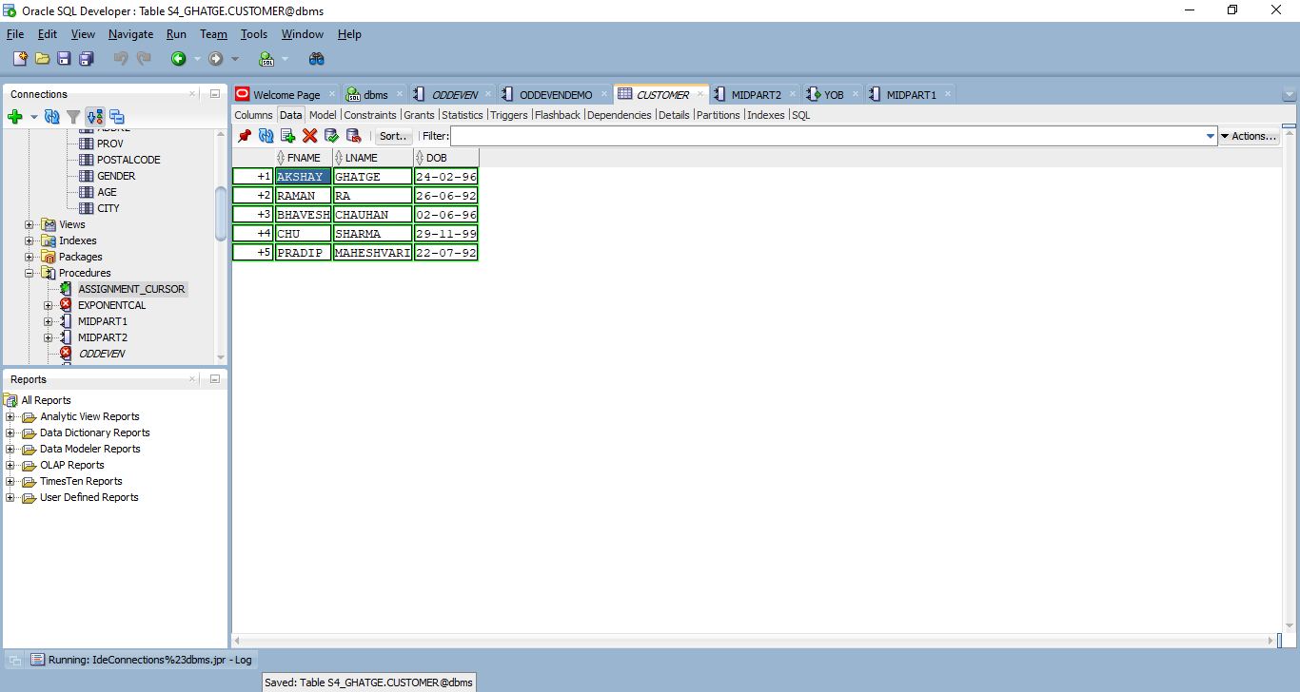

Part 3

Take a screenshot of the output window in SQL Developer and paste the image here

